Name: Noah Nguyen

R Lab 0: Introduction to R and RStudio
Please answer all the Exercises and the questions from the “On Your Own” section. If you use
any graphs or charts to justify your answer, please include them.
Exercise 1: What command would you use to extract just the counts of girls baptized?
arbuthnot$girls
Exercise 2: Is there an apparent trend in the number of girls baptized over the years?
How would you describe it? (Include plot)
A plot of the number of girls baptized over the years:
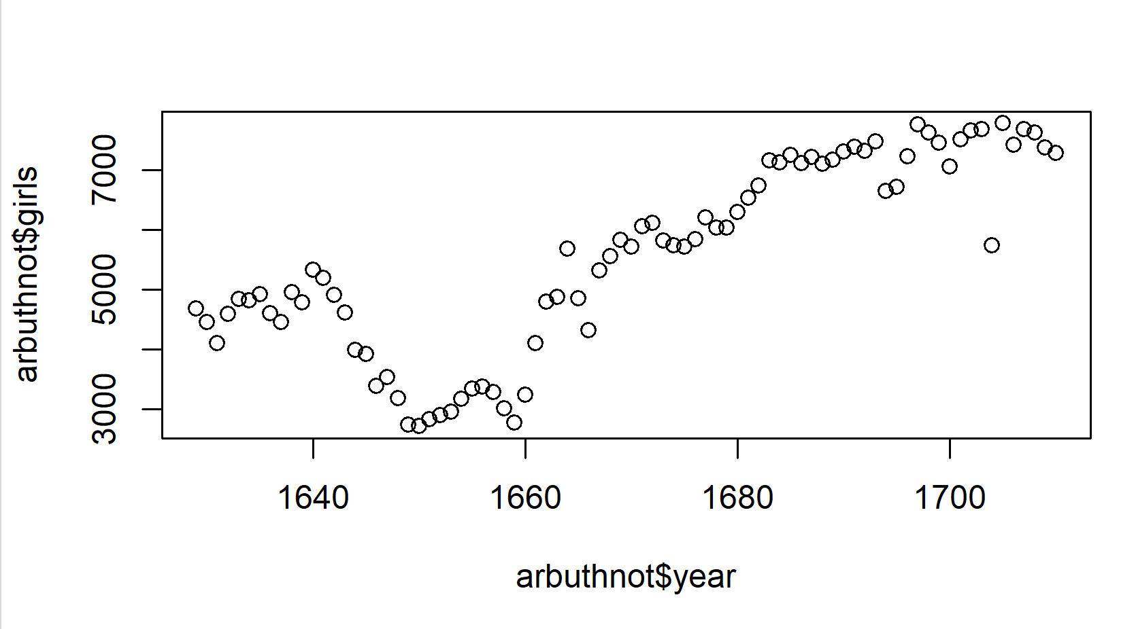
I see a positive linear trend since more girls are baptized each year than in the previous year.
From 1629 to 1640, the number of girls baptized fell and rose.
From the 1640s to the 1650s, the number of girls baptized gradually decreased.
The number of girls baptized continued to rise and fall until 1660.
From the 1660s to the 1700s, the number of girls baptized increased with some slight drops at some years.
Exercise 3: Now, make a plot of the proportion of boys over time. What do you see? (Include plot)
A plot of the proportion of boys baptized over time:
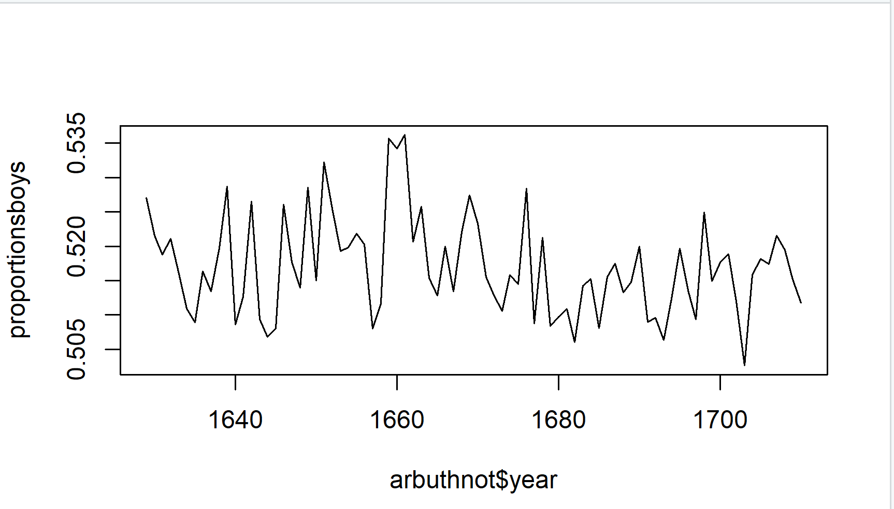
The number of boys baptized each year fluctuated, so there’s no apparent trend seeing in the proportion of boys baptized over time.
On Your Own:
1) What years are included in this data set? What are the dimensions of the data frame and
what are the variable or column names?
The data set includes the years from 1940 to 2002.
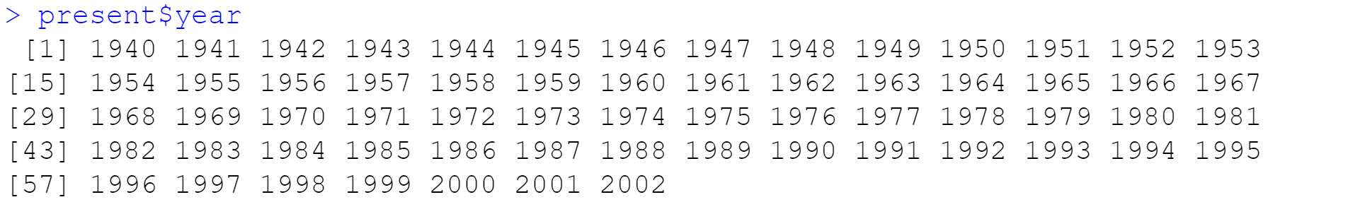
The dimensions of the data frame are [1] 63 3.
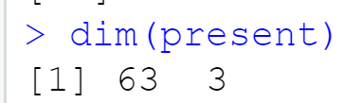
The variables/ column names are [1] “years” “boys” “girls”.
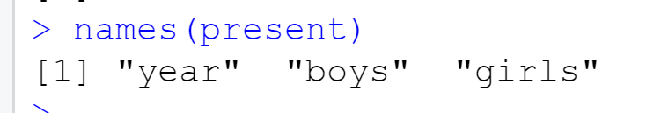
2) How do these counts compare to Arbuthnot’s? Are they on a similar scale?
The Arbuthnot’s are lower than the Present’s because the Arbuthnot’s count from 1629 to 1710 while the Present’s count from 1940 to 2002.
The Arbuthnot’s has the same variables/ column names and dimensions as the Present’s, so they are on a similar scale.
3) Make a plot that displays the boy-to-girl ratio for every year in the data set. What do you see? Does Arbuthnot’s observation about boys being born in greater proportion than girls hold up in the U.S.? Include the plot in your response.
A plot displays the boy-to-girl ratio for every year in the data set:
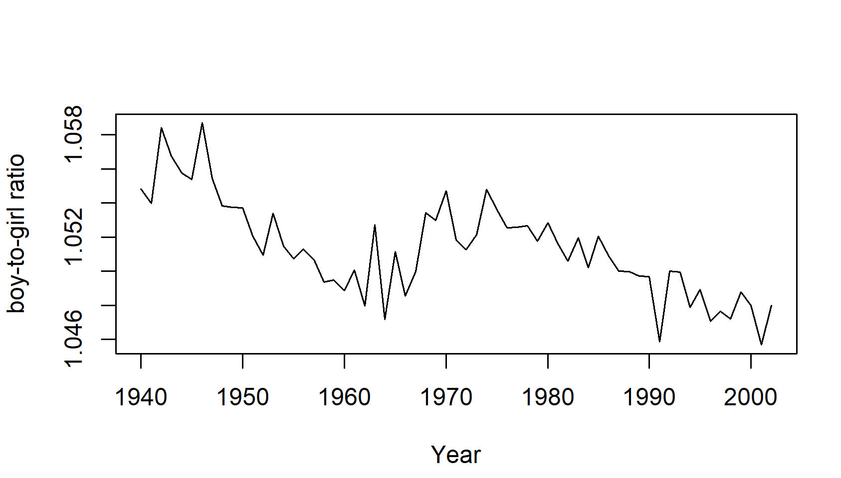
The plot does indicate that Arbuthnot’s observation about boys being born in greater proportion than girls holds up in the US.
4) In what year did we see the most total number of births in the U.S.?
In 1961, we see the most total number of births in the US, which is 4268326.

R Lab 1: Introduction to data
Please answer all the Exercises and the questions from the “On Your Own” section. If you use any graphs or charts to justify your answer, please include them.
Exercise 1: How many cases are there in this data set? How many variables? For each variable, identify its data type (e.g. categorical, discrete).
There are 20000 cases in this data set.
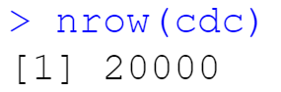
There are 9 variables in this data set.
The data type of each variable:
- Categorical data: “genhlth” “exerany” “hlthplan” “smoke100” and “gender”
- Discrete data: “height” “weight” “wtdesire” “age”
Exercise 2: Create a numerical summary for height and age, and compute the interquartile range for each. Compute the relative frequency distribution for gender and exerany. How many males are in the sample? What proportion of the sample reports being in excellent health?
Numerical summary for height:
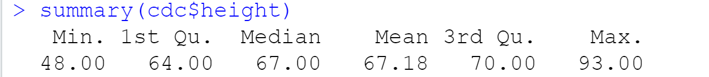
Numerical summary for age:
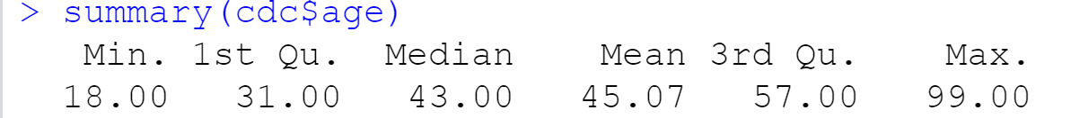
The interquartile range for height:
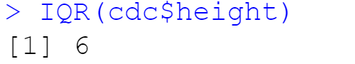
The interquartile range for age:
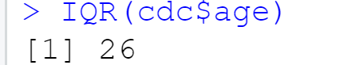
Relative frequency distribution for gender:
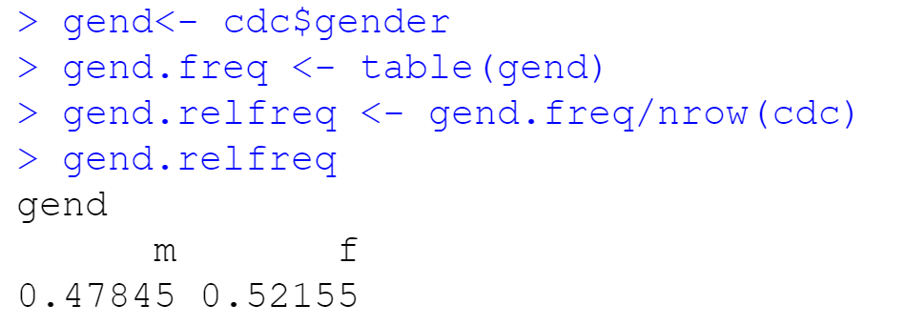
Relative frequency distribution for exerany:
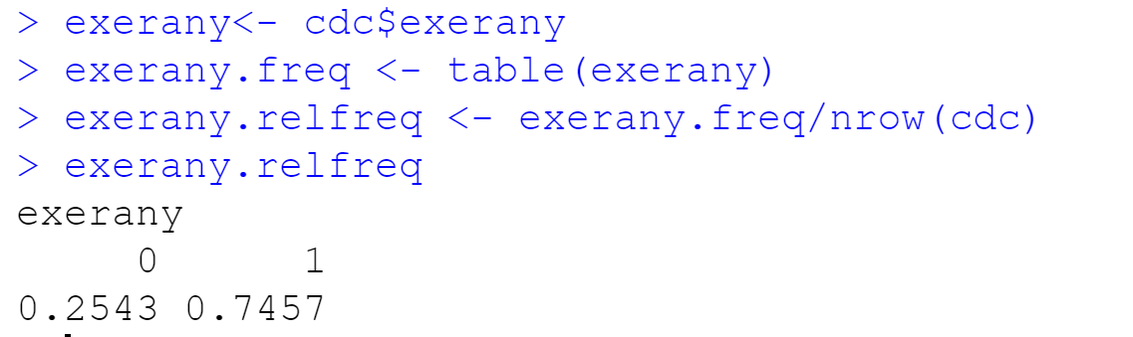
There are 9569 males in the sample.
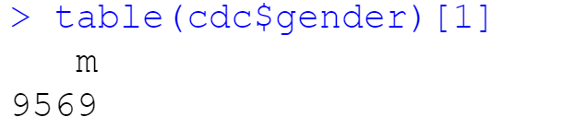
23.285% of the sample is reported to be in excellent health.
Exercise 3: What does the mosaic plot reveal about smoking habits and gender? (Include plot)
The mosaic plot reveals that the randomly selected male sample is more likely to smoke at least 100 cigarettes than the randomly selected female sample does.
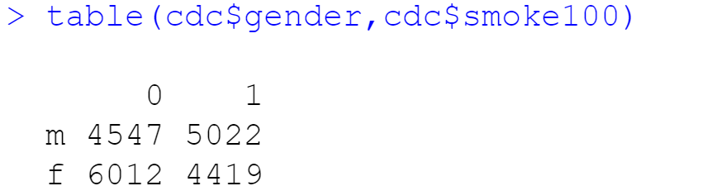
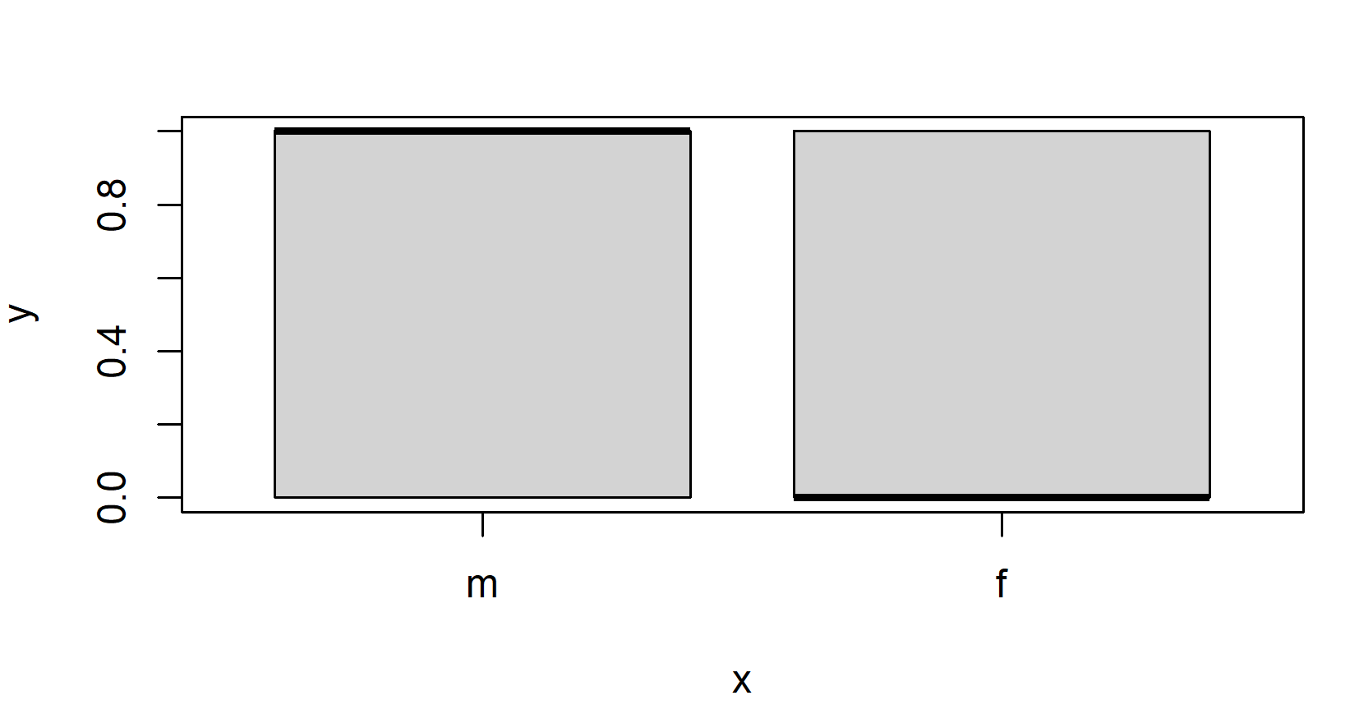
Exercise 4: Create a new object called under23_and_smoke that contains all observations of respondents under the age of 23 that have smoked 100 cigarettes in their lifetime. Write the command you used to create the new object as the answer to this exercise.
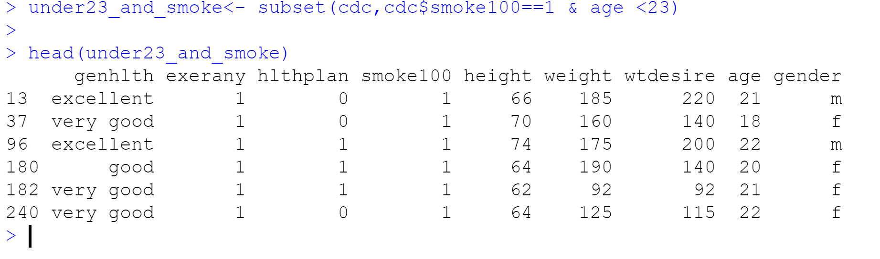
Exercise 5: What does this box plot show? Pick another categorical variable from the data set and see how it relates to BMI. List the variable you chose, why you might think it would have a relationship to BMI, and indicate what the figure seems to suggest. (Include plot)
We are using the box plot to compare data of different categories.
Box plot for bmi~general health:
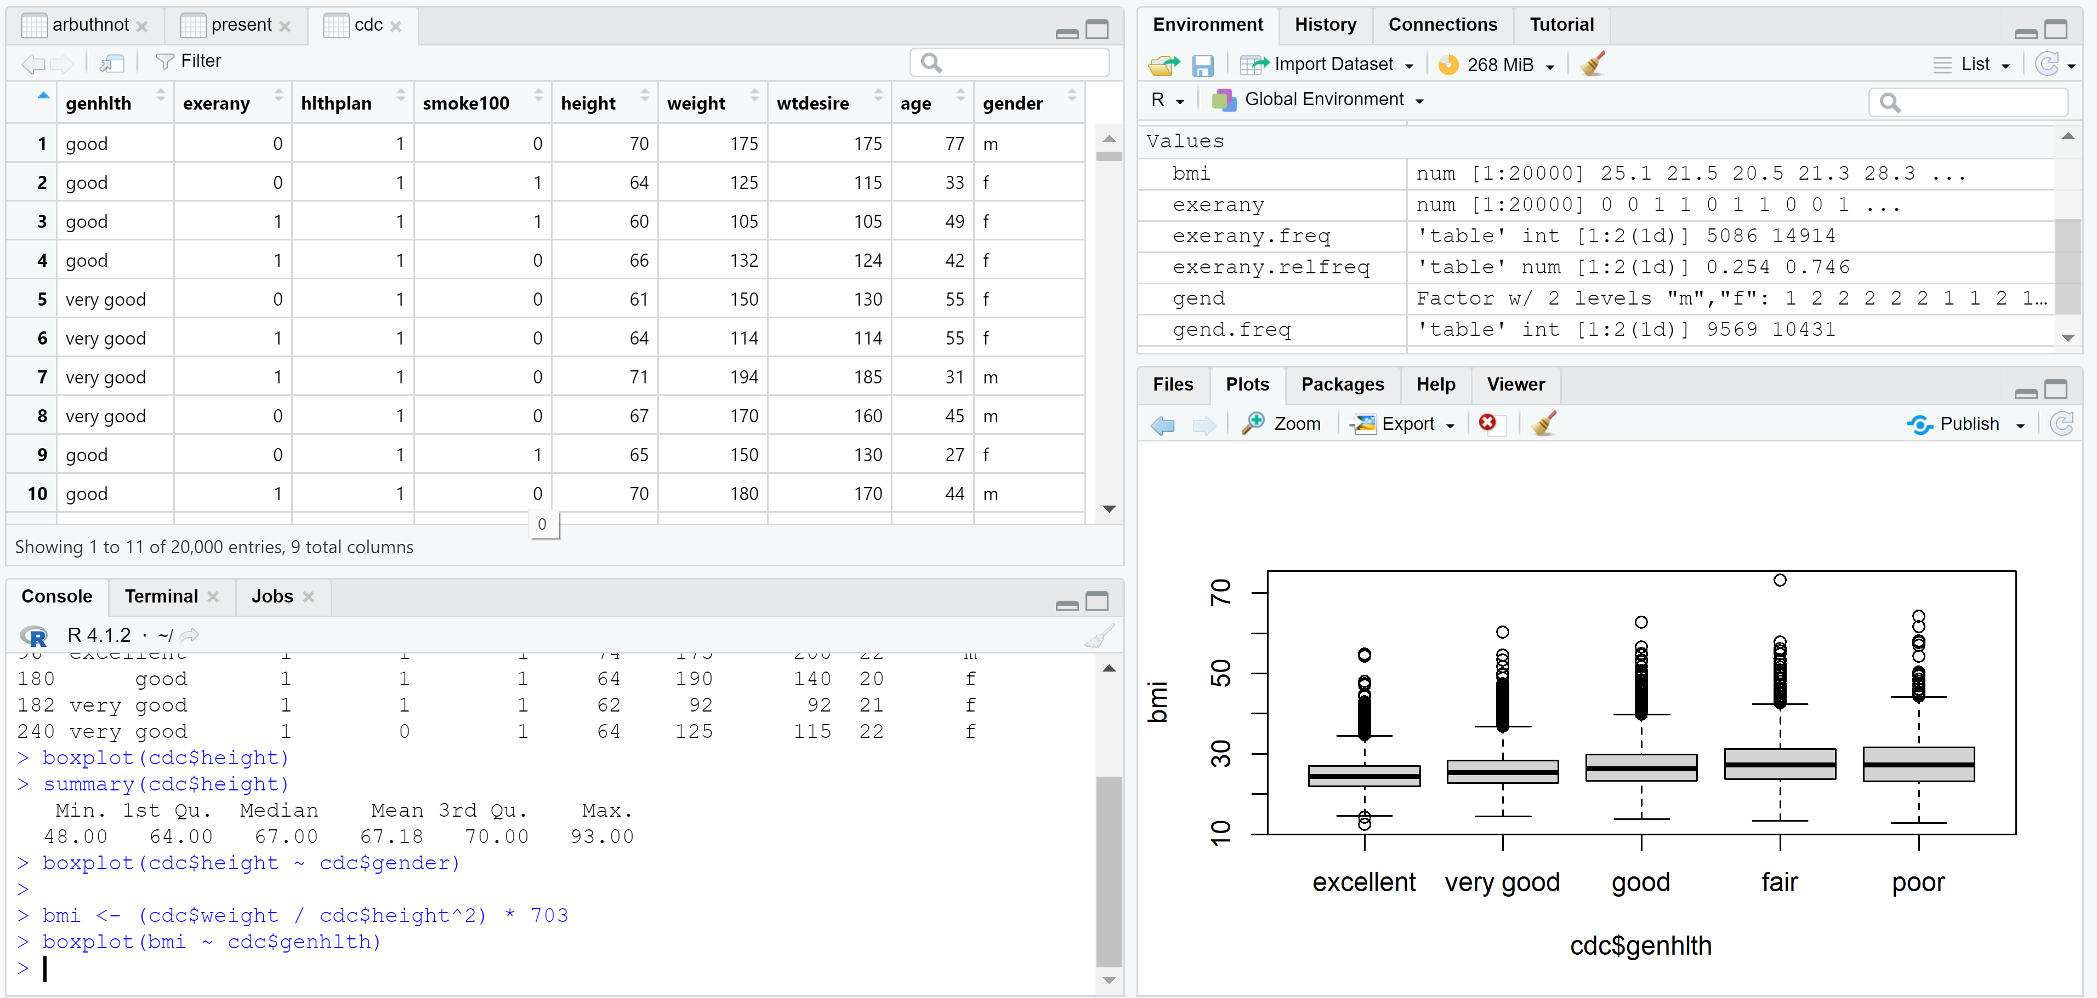
The box plot for bmi~gender:
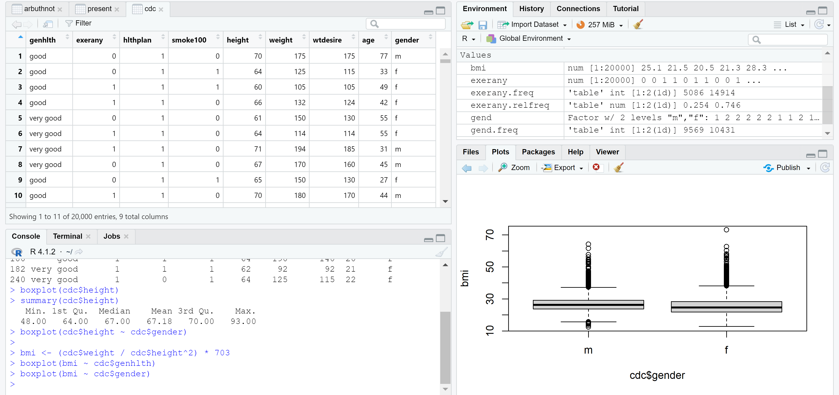
This box plot shows that the BMI is lower for females than it is for males.
On Your Own:
- Make a scatterplot of weight versus desired weight. Describe the relationship between these two variables. (Include plot)
A scatterplot of weight versus desired weight:
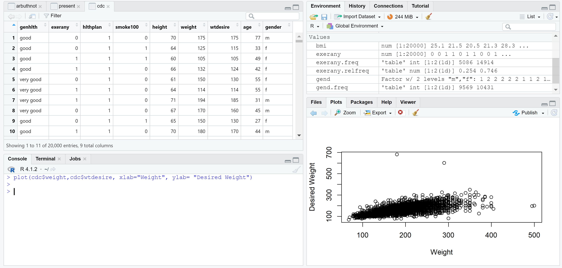
When the weight increases, the desired weight also increases. The weight and desired weight indeed have a direct relationship.
- Let’s consider a new variable: the difference between desired weight (wtdesire) and current weight (weight). Create this new variable by subtracting the two columns in the data frame and assigning them to a new object called wdiff.
To create a new object called wdiff, I used command:
wdiff is now created:
3) What type of data is wdiff? If an observation wdiff is 0, what does this mean about the
person’s weight and desired weight. What if wdiff is positive or negative?
wdiff is off integer type.
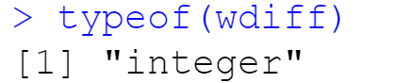
The person is underweight if wdiff is negative, and overweight if wdiff is positive. The person is at their desired weight if wdiff is 0.
4) Describe the distribution of wdiff in terms of its center, shape, and spread, including any
plots you use. What does this tell us about how people feel about their current weight?
The center is the mean of wdiff. We find the standard deviation of wdiff to determine the shape and spread. We plot the kernel density of wdiff. The plot below represents that most people have their current weight close to their desired weight.
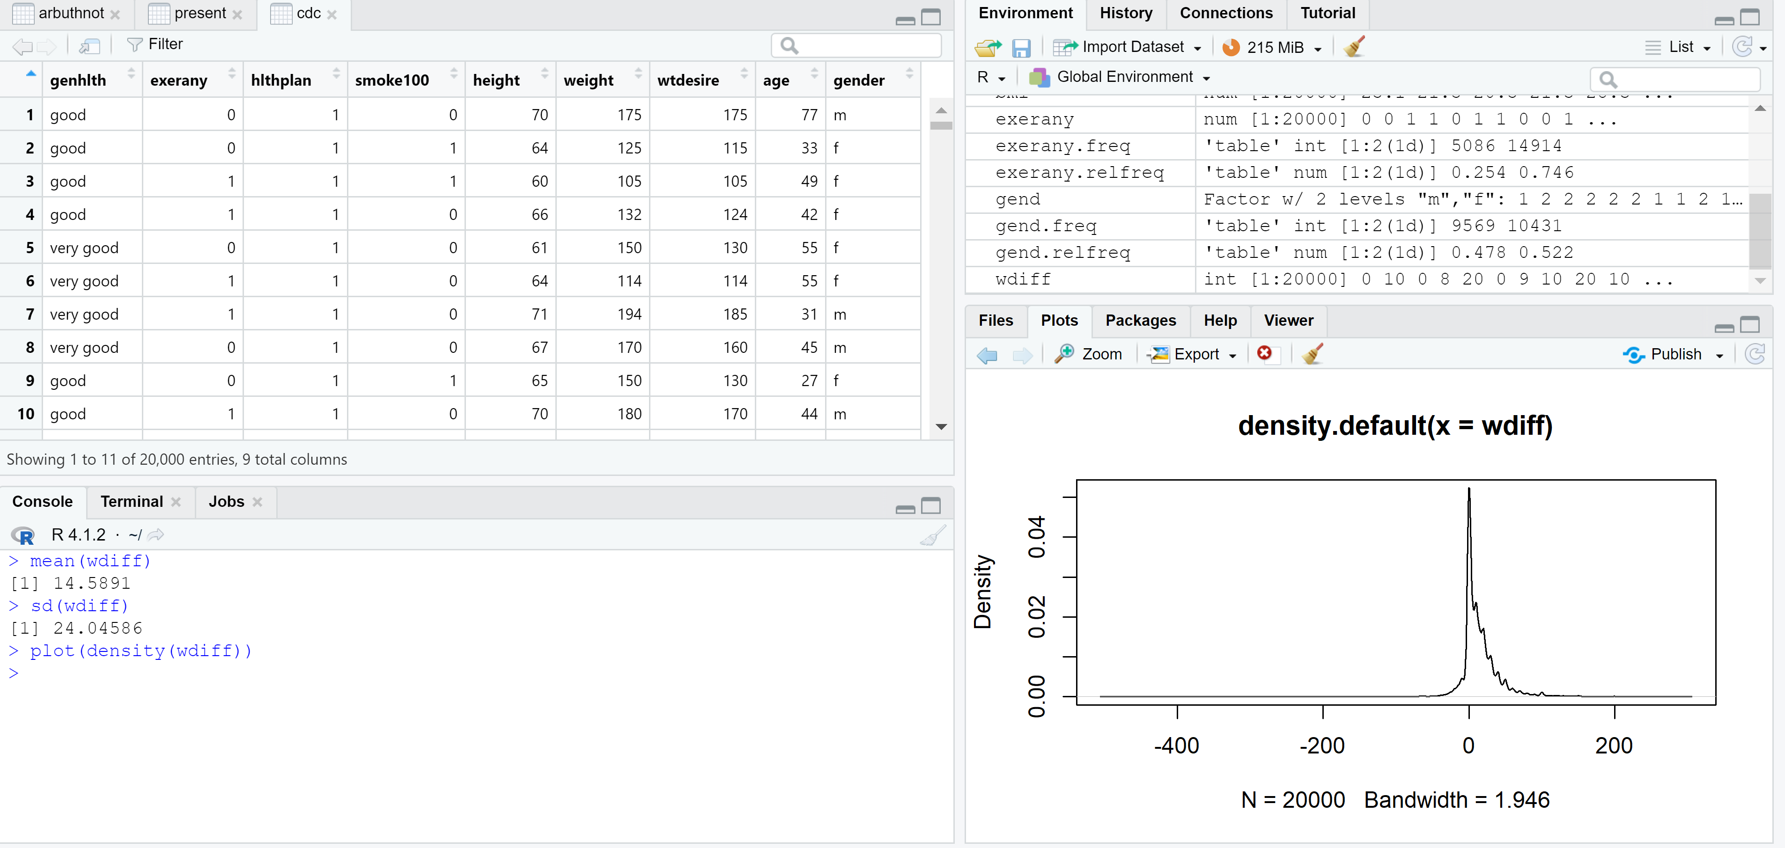
5) Using numerical summaries and a side-by-side box plot, determine if men tend to view their weight differently than women. (Include plot)
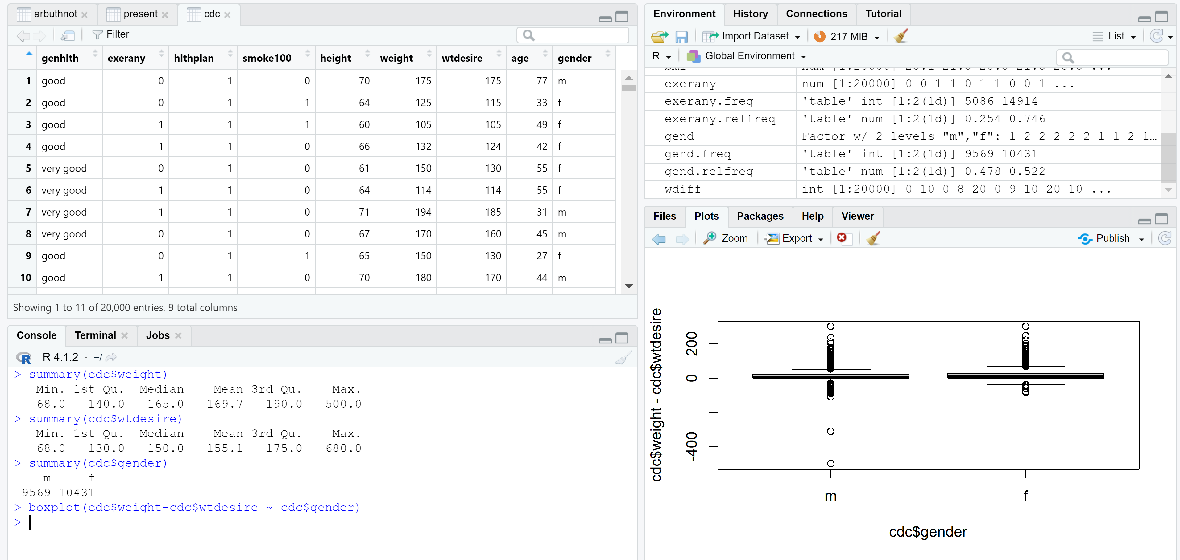
The box plot above indicates that both men and women have their current weight close to their desired weight (hence, the difference between current weight and desired weight is close to 0), so they have a similar view of weight.
6) Now it’s time to get creative. Find the mean and standard deviation of weight and determine what proportion of the weights are within one standard deviation of the mean.
The mean of weight:
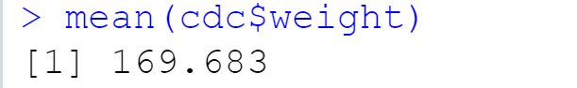
The standard deviation of weight:
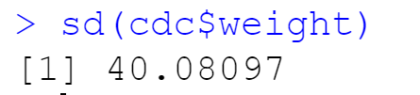
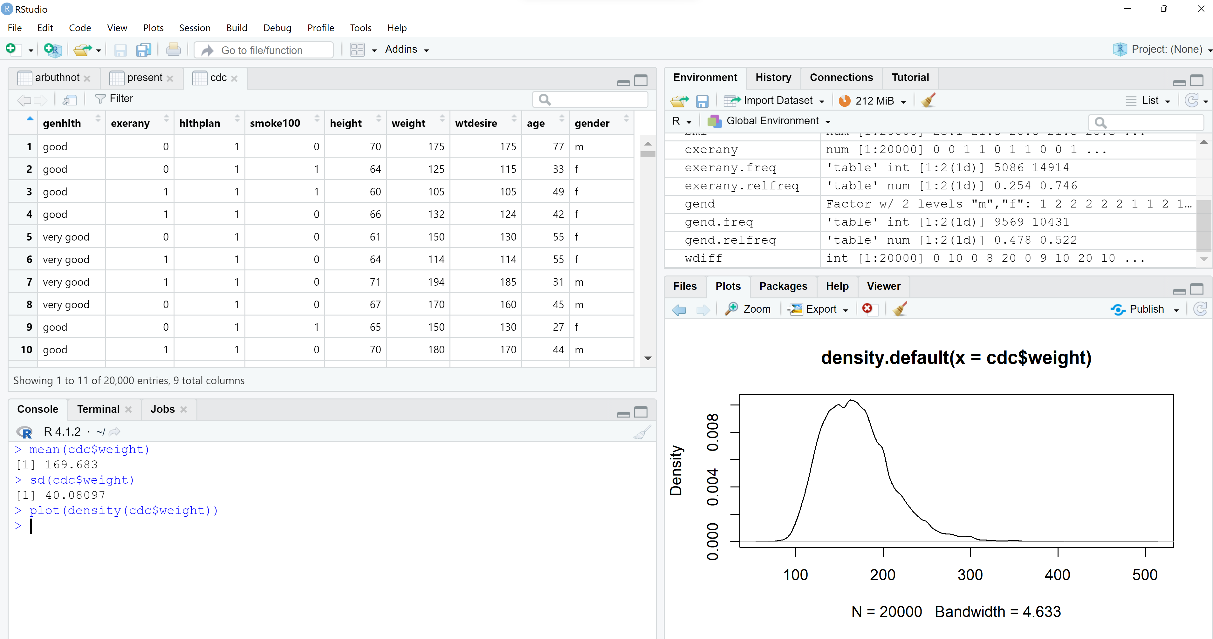
The plot indicates a normal distribution. Approximately 68% of the weights are within standard deviation of the mean.

